A Review of Biotic Interactions and Taxon Names Found in fkeck/gpt_interactions
by Nomer and Elton, two naive review bots
review@globalbioticinteractions.org
https://globalbioticinteractions.org/contribute
https://github.com/fkeck/gpt_interactions/issues
2025-02-27
Abstract
Life on Earth is sustained by complex interactions between organisms and their environment. These biotic interactions can be captured in datasets and published digitally. We present a review process of such an openly accessible digital interactions dataset of known origin, and discuss its outcome. The dataset under review, named fkeck/gpt_interactions, is 423MiB in size and contains 2,642,764 interaction with 16 unique types of associations (e.g., pathogenOf) between 28,253 primary taxon (e.g., Eukaryota) and 26,857 associated taxon (e.g., Eukaryota). The report includes detailed summaries of interactions data as well as a taxonomic review from multiple catalogs.
Table of Contents

Introduction

Data Review
Data review can be a time consuming process, especially when done manually. This review report aims to help facilitate data review of species interaction claims made in datasets registered with Global Biotic Interactions (Poelen, Simons, and Mungall 2014). The review includes summary statistics of, and observations about, the dataset under review:
(article?) {Keck2025.01.24.634685, author = {Keck, Fran{}ois and Broadbent, Henry and Altermatt, Florian},title = {Extracting massive ecological data on state and interactions of species using large language models},year = {2025},doi = {10.1101/2025.01.24.634685},journal = {bioRxiv}} https://github.com/fkeck/gpt_interactions/archive/24c1a83b16441b223073b19064b3a5e769aeb348.zip 2025-02-26T01:26:35.059Z d5e73bf940016d044c91695840e9de689823214a20f70066d56b258ccdba1d3a
For additional metadata related to this dataset, please visit https://github.com/fkeck/gpt_interactions and inspect associated metadata files including, but not limited to, README.md, eml.xml, and/or globi.json.

Methods
The review is performed through programmatic scripts that leverage tools like Preston, Elton, Nomer combined with third-party tools like grep, mlr, tail and head.
Tools used in this review process
tool name | version
elton | 0.15.1
nomer | 0.5.13
mlr | 6.0.0
pandoc | 3.1.6.1
The review process can be described in the form of the script below .
# get versioned copy of the dataset (size approx. 423MiB) under review
elton pull fkeck/gpt_interactions
# generate review notes
elton review fkeck/gpt_interactions\
> review.tsv
# export indexed interaction records
elton interactions fkeck/gpt_interactions\
> interactions.tsv
# export names and align them with the Catalogue of Life using Nomer
elton names fkeck/gpt_interactions\
| nomer append col\
> name-alignment.tsv
or visually, in a process diagram.
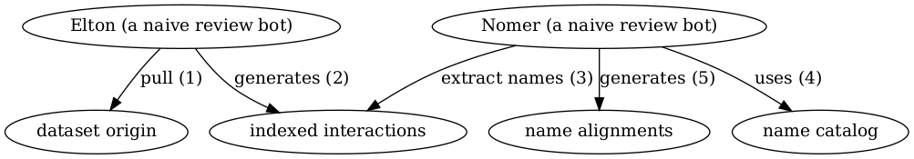
Review Process Overview
You can find a recent copy of the full review script at check-data.sh.

Results
In the following sections, the results of the review are summarized . Then, links to the detailed review reports are provided.

Biotic Interactions
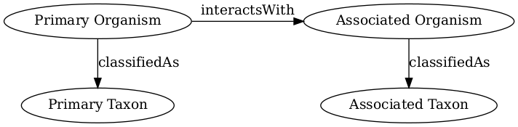
Biotic Interaction Data Model
In this review, biotic interactions (or biotic associations) are modeled as a primary (aka subject, source) organism interacting with an associate (aka object, target) organism. The dataset under review classified the primary/associate organisms with specific taxa. The primary and associate organisms The kind of interaction is documented as an interaction type.
The dataset under review, named fkeck/gpt_interactions, is 423MiB in size and contains 2,642,764 interaction with 16 unique types of associations (e.g., pathogenOf) between 28,253 primary taxon (e.g., Eukaryota) and 26,857 associated taxon (e.g., Eukaryota).
An exhaustive list of indexed interaction claims can be found in csv and tsv archives. To facilitate discovery, the first 500 claims available on the html page at indexed-interactions.html are shown below.
The exhaustive list was used to create the following data summaries below.
Sample of Indexed Interaction Claims
sourceTaxonName | interactionTypeName | targetTaxonName | referenceCitation
Eukaryota | eats | Eukaryota | https://pmc.ncbi.nlm.nih.gov/articles/PMC101375
Chordata | eats | Streptophyta | https://pmc.ncbi.nlm.nih.gov/articles/PMC101375
Mammalia | eats | Magnoliopsida | https://pmc.ncbi.nlm.nih.gov/articles/PMC101375
Proboscidea | eats | Fabales | https://pmc.ncbi.nlm.nih.gov/articles/PMC101375

Most Frequently Mentioned Interaction Types (up to 20 most frequent)
interactionTypeName | count
pathogenOf | 908492
interactsWith | 487372
eats | 388080
preysOn | 274218
parasiteOf | 212722
coOccursWith | 183814
vectorOf | 90402
hasHost | 51624
kills | 29428
symbiontOf | 11320
pollinates | 3284
hasRoost | 814
adjacentTo | 550
kleptoparasiteOf | 518
coRoostsWith | 90
eatenBy | 36

Most Frequently Mentioned Primary Taxa (up to 20 most frequent)
sourceTaxonName | count
Eukaryota | 374638
Chordata | 125454
Mammalia | 69254
Arthropoda | 63190
Platyhelminthes | 54190
Nematoda | 53758
Bacteria | 52198
Insecta | 39866
Chromadorea | 39030
Rhabditida | 37810
Carnivora | 34080
Trematoda | 33336
Pseudomonadota | 25504
Aves | 22092
Viruses | 17578
Gammaproteobacteria | 16536
Cestoda | 14406
Actinopteri | 14152
Felidae | 13218

Most Frequently Mentioned Associate Taxa (up to 20 most frequent)
targetTaxonName | count
Eukaryota | 413072
Chordata | 230834
Mammalia | 143092
Homo | 75650
Arthropoda | 51242
Streptophyta | 50348
Primates | 45640
Hominidae | 40074
Magnoliopsida | 36812
Artiodactyla | 36104
Actinopteri | 35152
Insecta | 30318
Bacteria | 29104
Aves | 25794
Carnivora | 25532
Mollusca | 23884
Rodentia | 21510
Gastropoda | 17550
Bovidae | 17146

Most Frequent Interactions between Primary and Associate Taxa (up to 20 most frequent)
sourceTaxonName | interactionTypeName | targetTaxonName | count
Eukaryota | pathogenOf | Eukaryota | 110556
Eukaryota | eats | Eukaryota | 68702
Eukaryota | interactsWith | Eukaryota | 55640
Eukaryota | preysOn | Eukaryota | 43414
Eukaryota | parasiteOf | Eukaryota | 33652
Platyhelminthes | pathogenOf | Chordata | 32296
Nematoda | pathogenOf | Chordata | 31952
Chordata | preysOn | Chordata | 29406
Eukaryota | coOccursWith | Eukaryota | 22840
Chromadorea | pathogenOf | Mammalia | 22138
Bacteria | pathogenOf | Eukaryota | 21062
Mammalia | preysOn | Mammalia | 16548
Chordata | eats | Chordata | 16514
Bacteria | interactsWith | Eukaryota | 14780
Trematoda | pathogenOf | Mammalia | 14120
Eukaryota | vectorOf | Eukaryota | 12854
Chordata | eats | Arthropoda | 12200
Chordata | eats | Streptophyta | 10992
Chordata | interactsWith | Chordata | 10804

Interaction Networks
The figures below provide a graph view on the dataset under review. The first shows a summary network on the kingdom level, and the second shows how interactions on the family level. It is important to note that both network graphs were first aligned taxonomically using the Catalogue of Life. Please refer to the original (or verbatim) taxonomic names for a more original view on the interaction data.
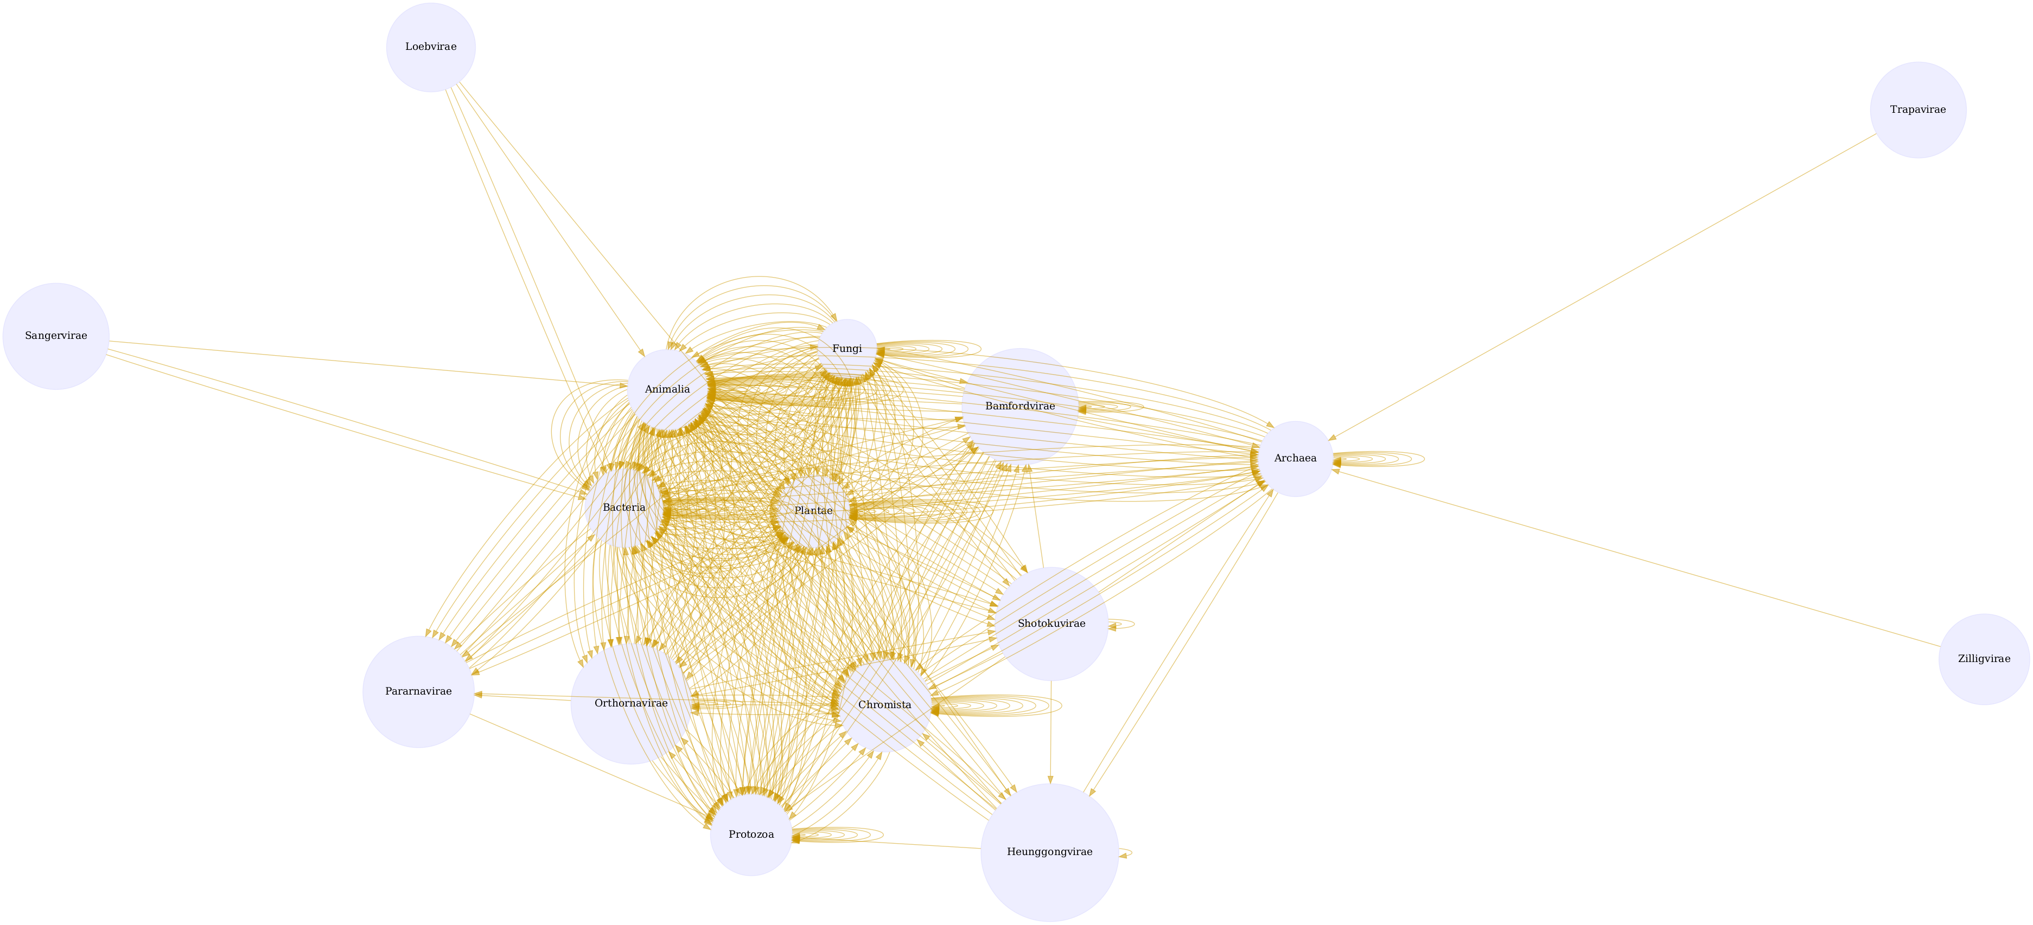
Interactions on taxonomic kingdom rank as interpreted by the Catalogue of Life download svg
Interactions on the taxonomic family rank as interpreted by the Catalogue of Life. download svg
You can download the indexed dataset under review at indexed-interactions.csv. A tab-separated file can be found at indexed-interactions.tsv
Learn more about the structure of this download at GloBI website, by opening a GitHub issue, or by sending an email.
Another way to discover the dataset under review is by searching for it on the GloBI website.

Taxonomic Alignment
As part of the review, all names are aligned against various name catalogs (e.g., col, ncbi, discoverlife, gbif, itis, wfo, mdd, tpt, pbdb, and worms). These alignments can help review name usage or aid in selecting of a suitable taxonomic name resource.
Sample of Name Alignments
providedName | relationName | resolvedCatalogName | resolvedName
Sciurus | HAS_ACCEPTED_NAME | col | Sciurus
Hysteriaceae | HAS_ACCEPTED_NAME | col | Hysteriaceae
Galeopsis tetrahit | HAS_ACCEPTED_NAME | col | Galeopsis tetrahit
Pimpinella major | HAS_ACCEPTED_NAME | col | Pimpinella major

Distribution of Taxonomic Ranks of Aligned Names by Catalog. Names that were not aligned with a catalog are counted as NAs. So, the total number of unaligned names for a catalog will be listed in their NA row.
resolvedCatalogName | resolvedRank | count
col | NA | 6054
col | class | 249
col | family | 3465
col | genus | 11540
col | gigaclass | 1
col | infraclass | 3
col | infraorder | 13
col | infraphylum | 1
col | kingdom | 3
col | megaclass | 1
col | nanorder | 3
col | order | 827
col | parvorder | 1
col | parvphylum | 1
col | phylum | 71
col | realm | 1
col | section | 2
col | species | 18260
col | subclass | 21
col | subfamily | 111
col | subgenus | 209
col | suborder | 35
col | subphylum | 5
col | subspecies | 408
col | subterclass | 1
col | subtribe | 3
col | superclass | 1
col | superfamily | 55
col | superorder | 3
col | tribe | 23
col | unranked | 2
col | variety | 35
discoverlife | NA | 40943
discoverlife | species | 22
gbif | NA | 2979
gbif | class | 289
gbif | family | 3826
gbif | form | 7
gbif | genus | 12273
gbif | kingdom | 6
gbif | order | 910
gbif | phylum | 95
gbif | species | 21045
gbif | subspecies | 446
gbif | variety | 90
itis | NA | 14746
itis | class | 181
itis | division | 15
itis | family | 3069
itis | genus | 8751
itis | infraclass | 4
itis | infrakingdom | 5
itis | infraorder | 10
itis | infraphylum | 1
itis | kingdom | 7
itis | order | 688
itis | phylum | 34
itis | section | 1
itis | species | 12926
itis | subclass | 34
itis | subdivision | 7
itis | subfamily | 108
itis | subgenus | 16
itis | subkingdom | 3
itis | suborder | 56
itis | subphylum | 11
itis | subspecies | 260
itis | superclass | 3
itis | superdivision | 2
itis | superfamily | 38
itis | superorder | 9
itis | tribe | 18
itis | variety | 16
mdd | NA | 40965
ncbi | NA | 1251
ncbi | biotype | 5
ncbi | clade | 66
ncbi | class | 301
ncbi | cohort | 2
ncbi | family | 3813
ncbi | genus | 12331
ncbi | infraclass | 3
ncbi | infraorder | 18
ncbi | kingdom | 3
ncbi | order | 1028
ncbi | parvorder | 4
ncbi | phylum | 107
ncbi | series | 1
ncbi | species | 21333
ncbi | species group | 1
ncbi | subclass | 43
ncbi | subfamily | 148
ncbi | subgenus | 100
ncbi | subkingdom | 1
ncbi | suborder | 44
ncbi | subphylum | 15
ncbi | subspecies | 354
ncbi | subtribe | 3
ncbi | superclass | 1
ncbi | superfamily | 53
ncbi | superkingdom | 4
ncbi | superorder | 9
ncbi | tribe | 40
ncbi | varietas | 2
pbdb | NA | 30848
pbdb | class | 103
pbdb | family | 1950
pbdb | genus | 4193
pbdb | infraclass | 6
pbdb | infraorder | 19
pbdb | kingdom | 4
pbdb | order | 460
pbdb | phylum | 52
pbdb | species | 3034
pbdb | subclass | 31
pbdb | subfamily | 118
pbdb | subgenus | 2
pbdb | subkingdom | 3
pbdb | suborder | 50
pbdb | subphylum | 6
pbdb | subspecies | 26
pbdb | subtribe | 2
pbdb | superclass | 4
pbdb | superfamily | 49
pbdb | superorder | 14
pbdb | superphylum | 3
pbdb | tribe | 19
pbdb | unranked clade | 102
tpt | NA | 35902
tpt | family | 285
tpt | genus | 1383
tpt | order | 58
tpt | species | 3335
tpt | specificepithet | 2
tpt | subspecificepithet | 2
wfo | NA | 35843
wfo | class | 7
wfo | family | 262
wfo | form | 1
wfo | genus | 1748
wfo | order | 72
wfo | section | 1
wfo | species | 3008
wfo | subclass | 1
wfo | subfamily | 1
wfo | subspecies | 26
wfo | subtribe | 1
wfo | tribe | 4
wfo | variety | 17
worms | NA | 19019
worms | class | 217
worms | family | 2958
worms | forma | 2
worms | genus | 8021
worms | gigaclass | 1
worms | infraclass | 6
worms | infrakingdom | 5
worms | infraorder | 14
worms | infraphylum | 1
worms | kingdom | 5
worms | megaclass | 1
worms | order | 829
worms | parvphylum | 1
worms | phylum | 43
worms | phylum (division) | 11
worms | section | 1
worms | species | 9607
worms | subclass | 36
worms | subfamily | 53
worms | subgenus | 8
worms | subkingdom | 2
worms | suborder | 34
worms | subphylum | 11
worms | subphylum (subdivision) | 6
worms | subspecies | 60
worms | subterclass | 1
worms | subtribe | 2
worms | superclass | 4
worms | superfamily | 40
worms | superorder | 6
worms | superphylum | 1
worms | tribe | 2
worms | variety | 12

Name relationship types per catalog. Name relationship type “NONE” means that a name was not recognized by the associated catalog. “SAME_AS” indicates either a “HAS_ACCEPTED_NAME” or “SYNONYM_OF” name relationship type. We recognize that “SYNONYM_OF” encompasses many types of nomenclatural synonymies (ICZN 1999) (e.g., junior synonym, senior synonyms).
resolvedCatalogName | relationName | count
col | HAS_ACCEPTED_NAME | 35202
col | NONE | 6266
col | SYNONYM_OF | 4977
discoverlife | NONE | 41262
discoverlife | HAS_ACCEPTED_NAME | 22
discoverlife | SYNONYM_OF | 4
gbif | HAS_ACCEPTED_NAME | 42979
gbif | SYNONYM_OF | 7448
gbif | NONE | 3193
itis | HAS_ACCEPTED_NAME | 25739
itis | NONE | 14966
itis | SYNONYM_OF | 1235
mdd | NONE | 39708
mdd | HAS_ACCEPTED_NAME | 1556
mdd | SYNONYM_OF | 20
ncbi | SAME_AS | 39863
ncbi | NONE | 1374
ncbi | SYNONYM_OF | 493
ncbi | COMMON_NAME_OF | 1
pbdb | HAS_ACCEPTED_NAME | 10111
pbdb | NONE | 31112
pbdb | SYNONYM_OF | 636
tpt | HAS_ACCEPTED_NAME | 5195
tpt | NONE | 36208
tpt | SYNONYM_OF | 300
wfo | NONE | 36146
wfo | HAS_ACCEPTED_NAME | 4880
wfo | SYNONYM_OF | 692
wfo | HAS_UNCHECKED_NAME | 321
worms | HAS_ACCEPTED_NAME | 21617
worms | NONE | 19257
worms | SYNONYM_OF | 1469

List of Available Name Alignment Reports
catalog name | alignment results
col | associated names alignments (first 500, full csv/tsv)
ncbi | associated names alignments (first 500, full csv/tsv)
discoverlife | associated names alignments (first 500, full csv/tsv)
gbif | associated names alignments (first 500, full csv/tsv)
itis | associated names alignments (first 500, full csv/tsv)
wfo | associated names alignments (first 500, full csv/tsv)
mdd | associated names alignments (first 500, full csv/tsv)
tpt | associated names alignments (first 500, full csv/tsv)
pbdb | associated names alignments (first 500, full csv/tsv)
worms | associated names alignments (first 500, full csv/tsv)

Additional Reviews
Elton, Nomer, and other tools may have difficulties interpreting existing species interaction datasets. Or, they may misbehave, or otherwise show unexpected behavior. As part of the review process, detailed review notes are kept that document possibly misbehaving, or confused, review bots. An sample of review notes associated with this review can be found below.
First few lines in the review notes.
reviewDate | reviewCommentType | reviewComment
2025-02-27T03:50:42Z | note | found unsupported interaction type with name: [contribute]
2025-02-27T03:50:42Z | note | found unsupported interaction type with name: [contribute]
2025-02-27T03:50:42Z | note | found unsupported interaction type with name: [contribute]
2025-02-27T03:50:42Z | note | found unsupported interaction type with name: [separate]
In addtion, you can find the most frequently occurring notes in the table below.
Most frequently occurring review notes, if any.
reviewComment | count
found unsupported interaction type with name: [invade] | 7818
found unsupported interaction type with name: [exclude] | 3296
found unsupported interaction type with name: [rely on] | 2874
found unsupported interaction type with name: [lyse] | 2698
For addition information on review notes, please have a look at the first 500 Review Notes or the download full csv or tsv archives.

GloBI Review Badge
As part of the review, a review badge is generated. This review badge can be included in webpages to indicate the review status of the dataset under review.
Picture of a GloBI Review Badge
Note that if the badge is green, no review notes were generated. If the badge is yellow, the review bots may need some help with interpreting the species interaction data.

GloBI Index Badge
If the dataset under review has been registered with GloBI, and has been succesfully indexed by GloBI, the GloBI Index Status Badge will turn green. This means that the dataset under review was indexed by GloBI and is available through GloBI services and derived data products.
Picture of a GloBI Index Badge
If you’d like to keep track of reviews or index status of the dataset under review, please visit [GloBI’s dataset index ^[At time of writing (2025-02-27) the version of the GloBI dataset index was available at https://globalbioticinteractions.org/datasets for badge examples.

Discussion
This review aims to provide a perspective on the dataset to aid in understanding of species interaction claims discovered. However, it is important to note that this review does not assess the quality of the dataset. Instead, it serves as an indication of the open-ness and FAIRness (Wilkinson et al. 2016; Trekels et al. 2023) of the dataset: to perform this review, the data was likely openly available, Findable, Accessible, Interoperable and Reusable. The current Open-FAIR assessment is qualitative, and a more quantitative approach can be implemented with specified measurement units.
This report also showcases the reuse of machine-actionable (meta)data, something highly recommended by the FAIR Data Principles (Wilkinson et al. 2016). Making (meta)data machine-actionable enables more precise procesing by computers, enabling even naive review bots like Nomer and Elton to interpret the data effectively. This capability is crucial for not just automating the generation of reports, but also for facilitating seamless data exchanges, promoting interoperability.

Acknowledgements
We thank the many humans that created us and those who created and maintained the data, software and other intellectual resources that were used for producing this review. In addition, we are grateful for the natural resources providing the basis for these human and bot activities. Also, thanks to https://github.com/zygoballus for helping improve the layout of the review tables.

Author contributions
Nomer was responsible for name alignments. Elton carried out dataset extraction, and generated the review notes.

References
ICZN. 1999. “International Code of Zoological Nomenclature.” The International Trust for Zoological Nomenclature, London, UK. https://www.iczn.org/the-code/the-code-online/.
Poelen, Jorrit H., James D. Simons, and Chris J. Mungall. 2014. “Global Biotic Interactions: An Open Infrastructure to Share and Analyze Species-Interaction Datasets.” Ecological Informatics 24 (November): 148–59. https://doi.org/10.1016/j.ecoinf.2014.08.005.
Trekels, Maarten, Debora Pignatari Drucker, José Augusto Salim, Jeff Ollerton, Jorrit Poelen, Filipi Miranda Soares, Max Rünzel, Muo Kasina, Quentin Groom, and Mariano Devoto. 2023. “WorldFAIR Project (D10.1) Agriculture-related pollinator data standards use cases report.” Zenodo. https://doi.org/10.5281/zenodo.8176978.
Wilkinson, Mark D., Michel Dumontier, IJsbrand Jan Aalbersberg, Gabrielle Appleton, Myles Axton, Arie Baak, Niklas Blomberg, et al. 2016. “The FAIR Guiding Principles for Scientific Data Management and Stewardship.” Scientific Data 3 (1). https://doi.org/10.1038/sdata.2016.18.

Note that you have to first get the data (e.g., via elton pull fkeck/gpt_interactions) before being able to generate reviews (e.g., elton review fkeck/gpt_interactions), extract interaction claims (e.g., elton interactions fkeck/gpt_interactions), or list taxonomic names (e.g., elton names fkeck/gpt_interactions)
Disclaimer: The results in this review should be considered friendly, yet naive, notes from an unsophisticated robot. Please keep that in mind when considering the review results.
Up-to-date status of the GloBI Review Badge can be retrieved from the GloBI Review Depot
Up-to-date status of the GloBI Index Badge can be retrieved from GloBI’s API
According to http://opendefinition.org/: “Open data is data that can be freely used, re-used and redistributed by anyone - subject only, at most, to the requirement to attribute and sharealike.”

